8th April 2013

Group 2

Integrated Campus | SEN-Winter 2013

Integrated Campus

**User Manual**

**Final Increment**

**Revision History:**

|  |  |  |  |  |
| --- | --- | --- | --- | --- |
| **Version** | **Primary Author(s)** | **Description of Version** | **Reviewed By** | **Date Completed** |
| v_2.3(Final) | Pinky .J. Meena, | This is the Final increment version of  User Manual. | Ishita Agarwal | 13th March 2013 |

CONTENT

1. Introduction…………………………………………………………………3

2. Requirements……………………………………………………………… 3

3. Homepage…………………………………………………………………..3

4. General Logged In Page …………………………………………………..5

5. Student Logged in Page……………………………………………………7

6. Student Courses Page……………………………………………………..8

7. Faculty logged in Page ……………………………………………………12

8. Faculty Course Page ………………………………………………………14

9. Admin logged In Page ……………………………………………………..23

10. Teaching Assistant Logged In Page …………………………………….26

1.INTRODUCTION

This user manual aims at acquainting the user with the basic know-how of the website. All the main functions and pages of the website are included in this user manual. The pre-requirement of the user is his/her basic know-how in English language and a working knowledge of computers. The primary functions of this website include providing an online platform for a professor to conduct polls, upload attendance, send warning SMS to students with attendance below a threshold and upload course material. Other secondary functions include discussion forums, personalized timetable for each student and faculty, personalized notice board for each user. All the students and faculty are registered my administrator of the website, there is no automatic sign up.The functions and working of every page are discussed in detail below for the user to refer to.

Requirements:

**User Requirements**

The user is supposed to have a PC or laptop with internet connection and web browser for accessing the website.

Suggested browsers are:

* Mozilla Firefox 3.6+
* Google Chrome 4+
* Internet Explorer (cookies enabled)

Server Requirements:

The server requirements for running the back-end of the product are as follows:

* XAMPP
* Development Tools: Dreamweaver, Sublime Text Editor.
* Database Server.: MySQL

3.HOME PAGE

Features:  
  
**1. User Log in** – In order to access the site, user must have an account on the site which is provided by administration of the site.

Following steps need to be followed for signing in

* Enter username and password in the desired fields on home page
* Click on ‘Sign in’ button
* If the user name and password match the user is directed to home page else follow the above procedure again.

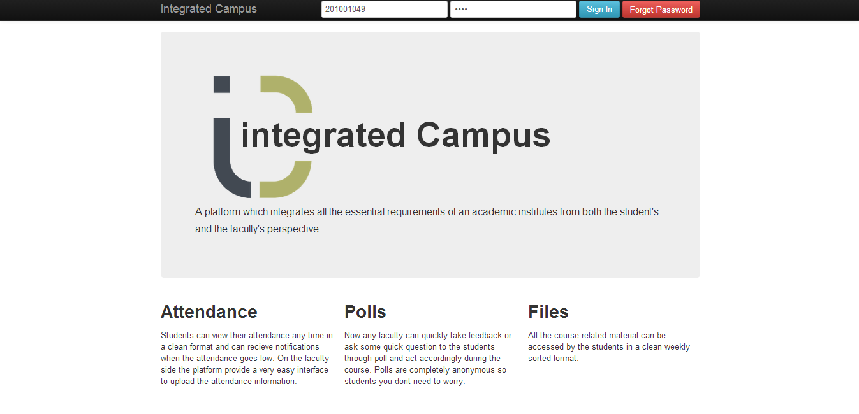

**2. Forget Password**- In case a user forgets his/her login password, our website has a feature to recover the password using the “Forgot Password” option. Clicking on “Forget Password “ gives a pop up window. The user has to enter his/her username. If the username exists he/she is sent a randomly generated password on their registered email id, which can be used to log in .

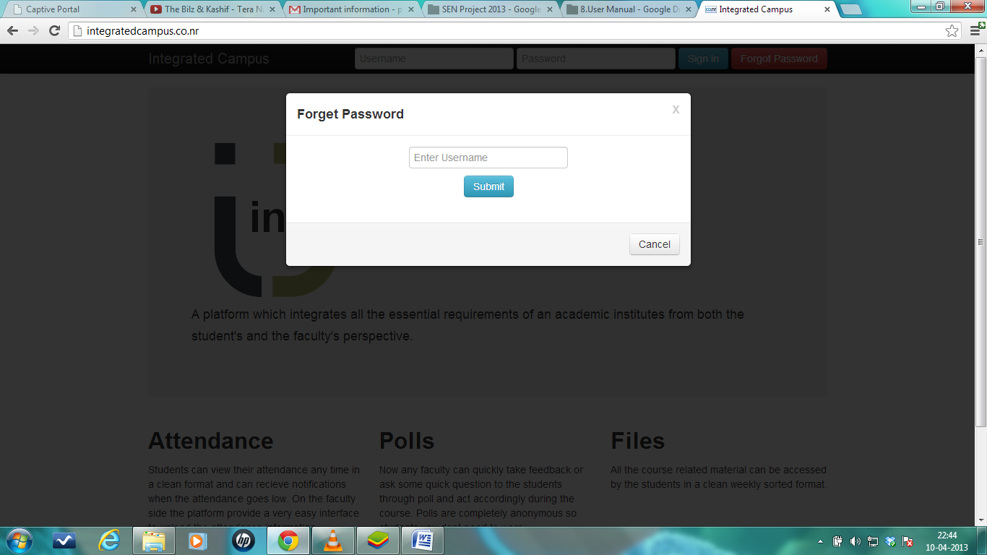

4. GENERAL LOGGED IN PAGE:

Features:

**1. Change Password:** The user can change his/her password by clicking his/ her name tab appearing on top right corner. A drop down list appears which contains an option of ‘Change Password’.

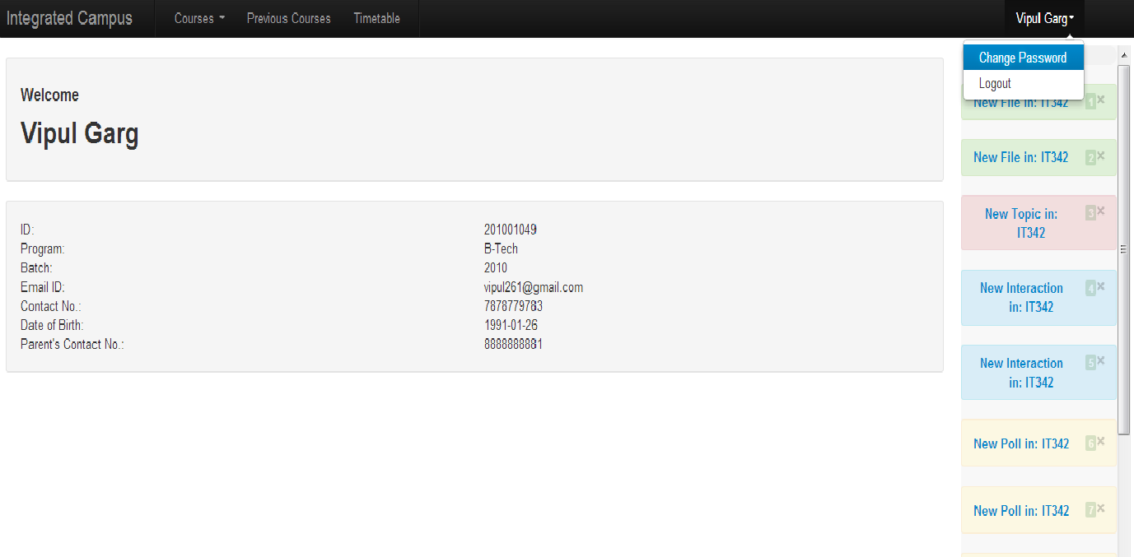

When the user clicks on “Change Password” a pop up appears, The user needs to fill his/her old and new password click on ‘Change’ button the to change his or her password.

On click of ‘Cancel’ the window disappears, the user is directed to the previous page.

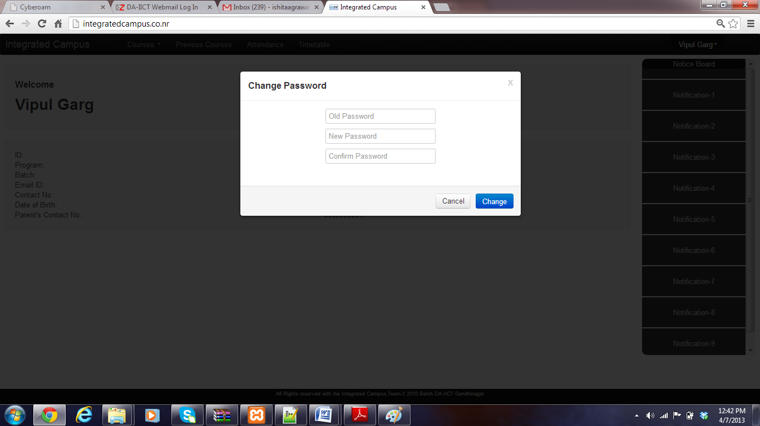

**2. Logout –** The user can logout by clicking his/ her name tab appearing on top right side corner. A drop down list appears which contains an option of ‘Logout’.

On clicking of ‘Logout’ the user is logged out and is direct back to login page of the site.

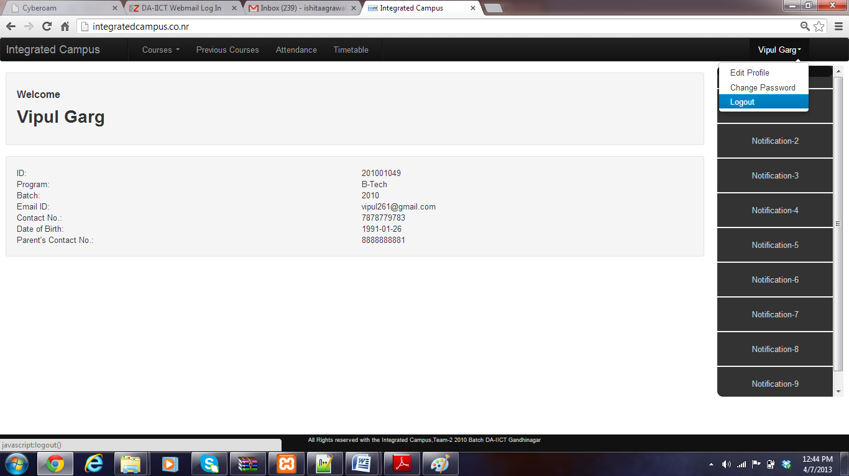

5. STUDENT LOGGED IN PAGE:

The user can view all his /her personal details and the notification on the home page.

Features:

1. **Current Courses**: The student can view his registered list of courses by clicking on ‘Courses’ tab. A dropdown of list of his/her courses appears. The user can select any course to go to the specific course page.

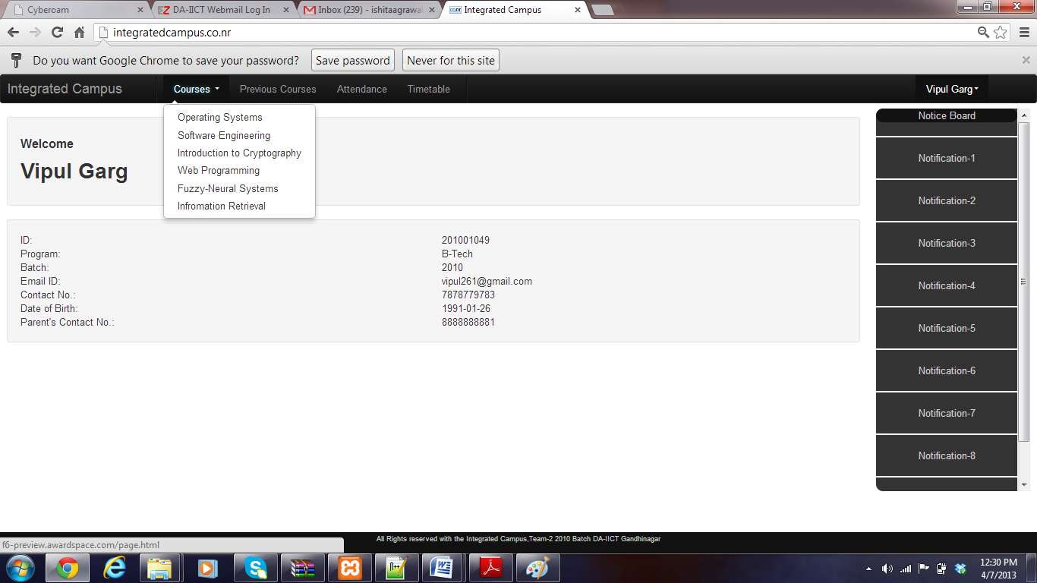

**2. Previous Courses** – Clicking on this tab the user is directed to a new page where can view all the previous courses he or she has been registered for. The user can view the courses he/she took by selecting respective year and semester.

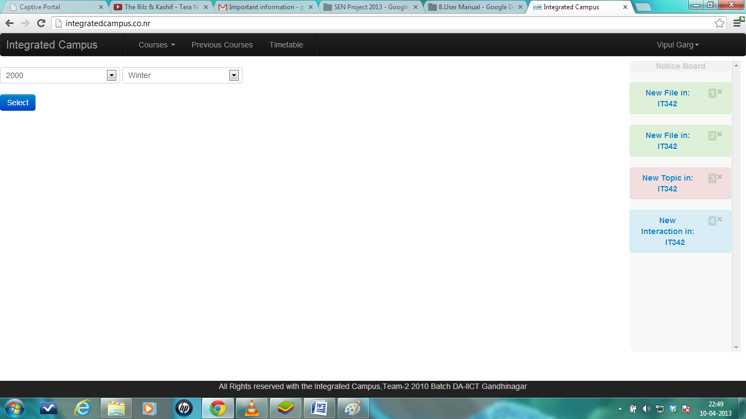

**4. Timetable**: Clicking on this tab, the user is directed to a page where he/she can see their personalized timetable.

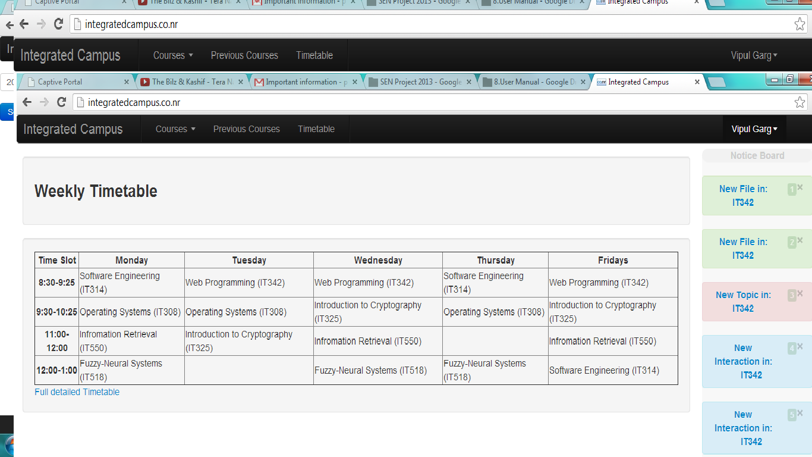

6.STUDENT COURSE PAGE

Student can see the course name ,introduction and credits of the course along with four tabs ‘Course Material’, ’Poll’, ’Attendance’, ’Forum’

**1. Course Material:** On clicking of course material tab the user can see all the files uploaded by the course instructor and the date and time of upload.

The user can view the specific file by clicking on the file name

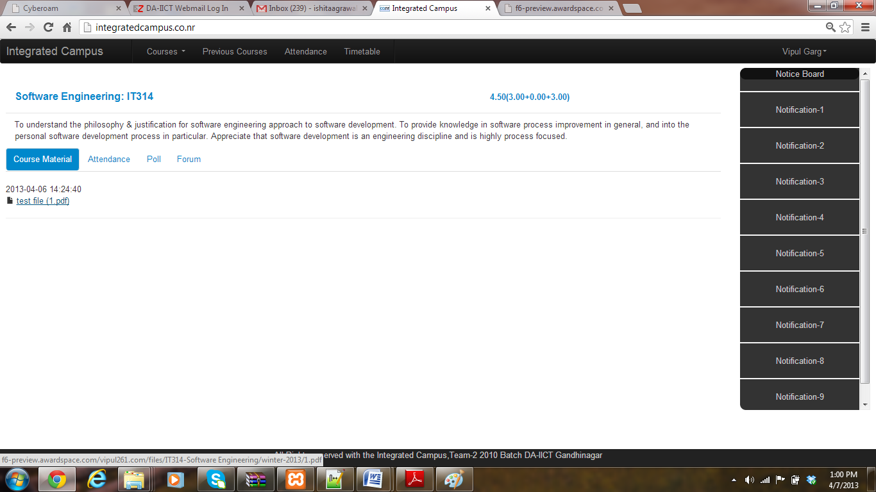

**2. Attendance**: By clicking this tab user can see his/her attendance in this course .Attendance of lab, lectures and tutorials can be seen independently.

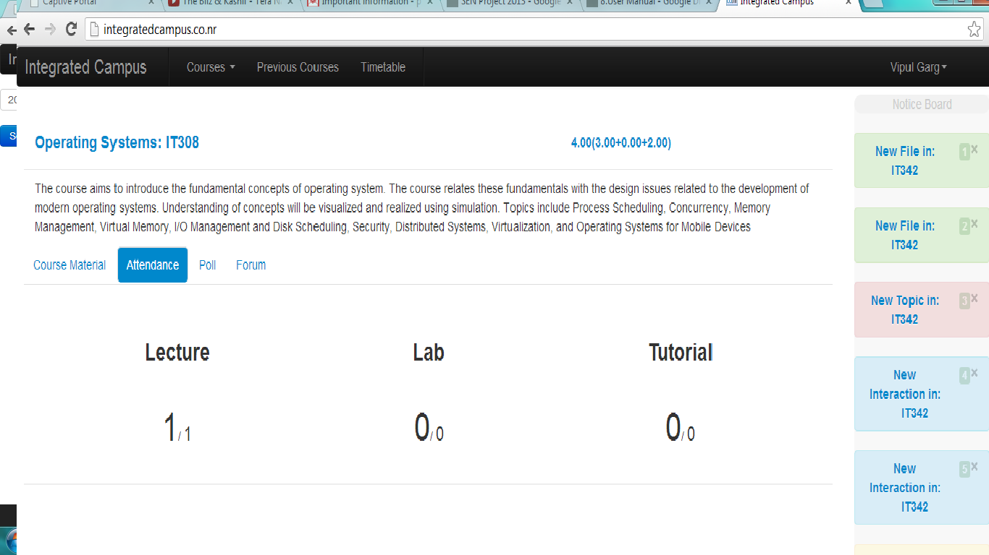

**3. Poll:** On click of this tab the user can see all the ongoing polls of the course. He/she can respond to the poll by selecting an option and clicking on ‘Submit’ button.

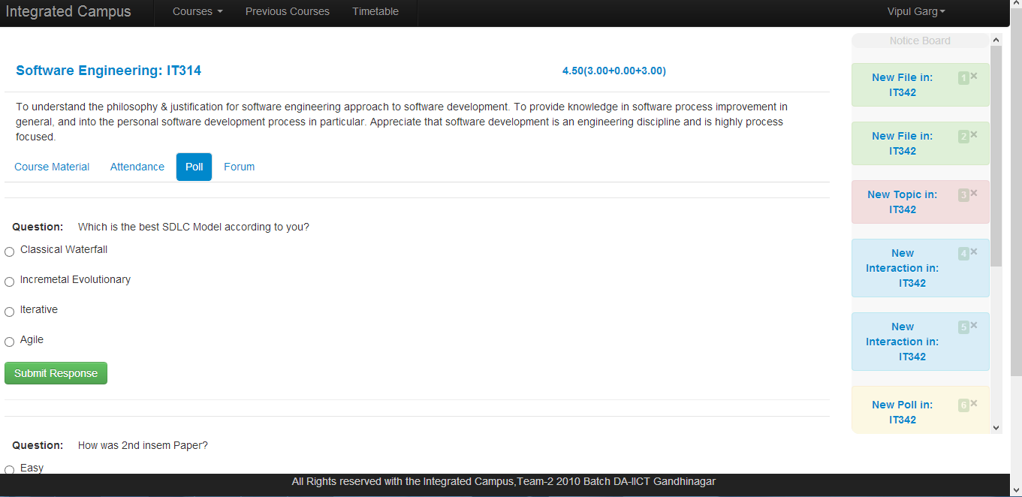

**4. Forum** – Clicking on this tab directs the user to a page where he/she can ‘Create Topic’ for forum, view existing topics and post responses for the existing and newly created topics.

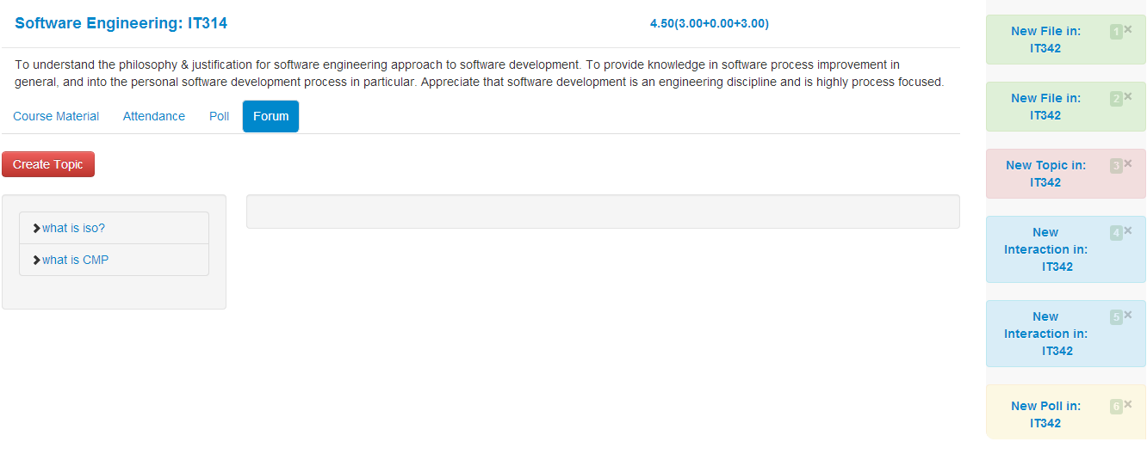

* **Create Topic** : On Click of this button the below window appears. The user needs to input the topic for discussion in the text box and click ‘GO!’ , for successful creation of new topic.

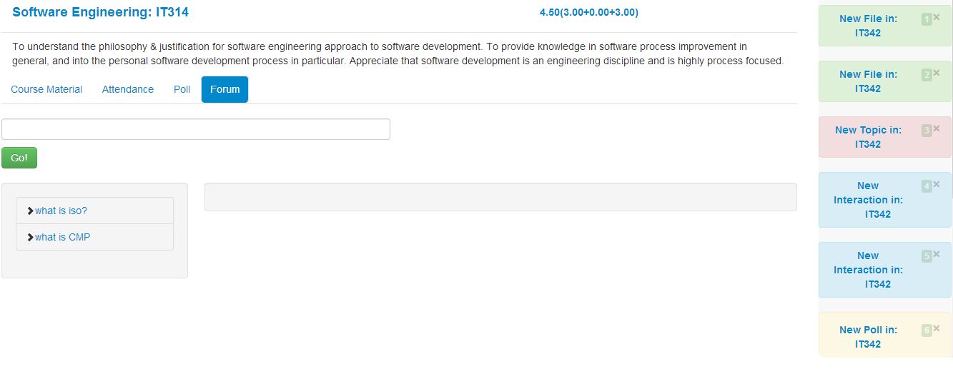

* **Entering Response** : The user can view all the responses to any specific topic by clicking on topic name .For giving a response the user needs to type his/her response in the provided textbox and click on ‘Submit’ button.

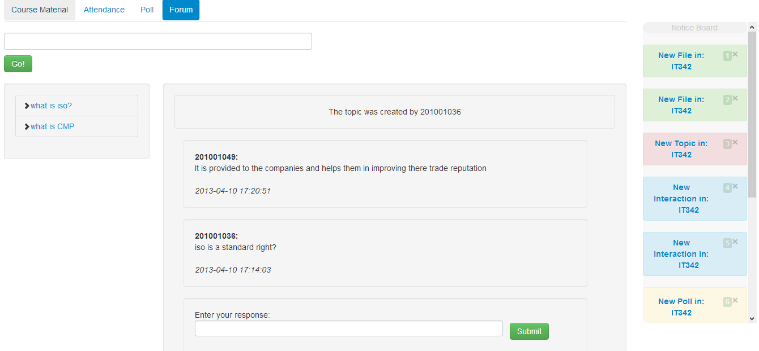

**5. Notice Board** –The user can view all the updates regarding the courses he/she is enrolled for in the notice board appearing in right side of the page.

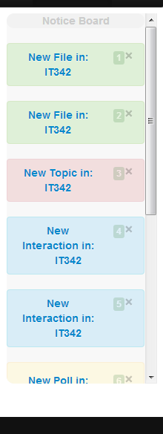

**6. Time table** - Clicking on this will redirect the Student to his/her personalized time table for the semester, showing a list of his daily schedule courses, only Admin can update the timetable.

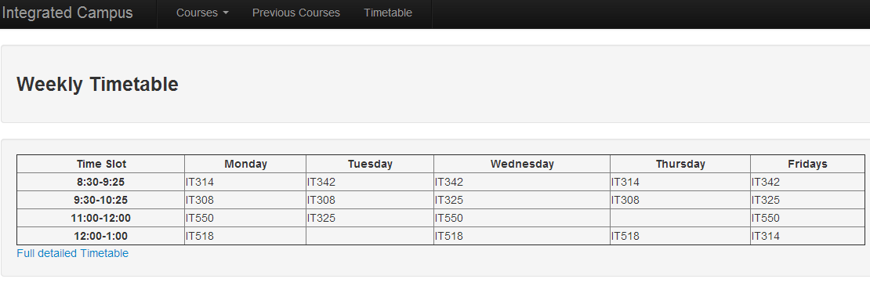

7.FACULTY LOGGED IN PAGE:

Features:

**1.Current Courses :** The faculty can view his/her current courses by click of ‘Courses’ tab.

He/she will get directed to specific course page , on choosing a course from the drop down list.

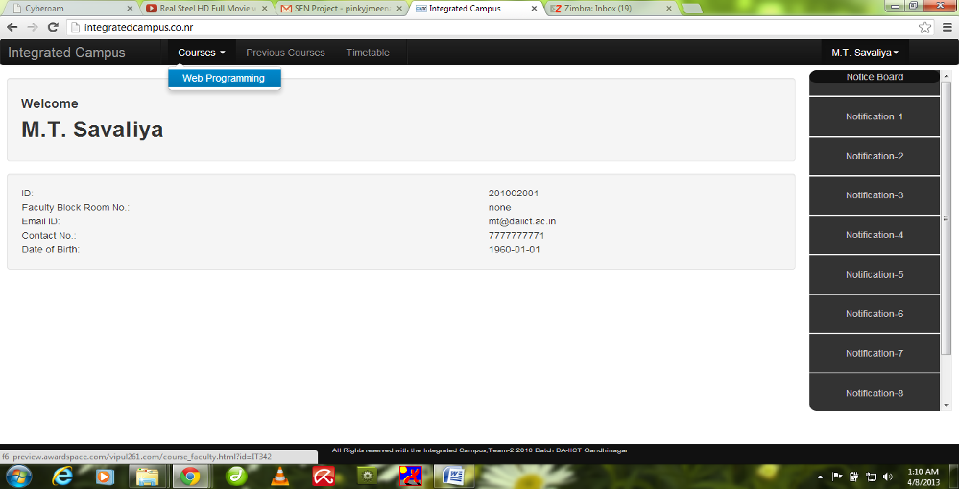

**2. Previous Courses** – Clicking on this tab user gets a drop down showing the list of all the previous courses he or she has been registered for. The user can view the courses he/she took by selecting respective year and semester.



**4. Timetable**: Clicking on this tab, the user is directed to a page where he/she can see their personalized timetable.

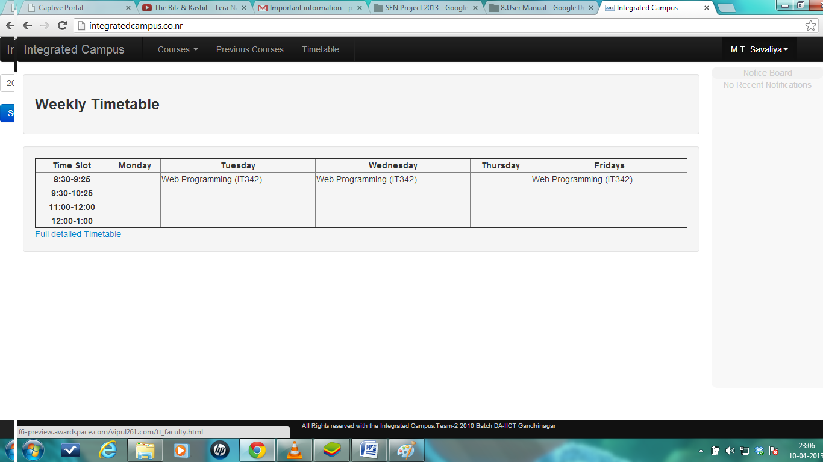

8.FACULTY COURSE PAGE

**1.Course Material :**The Professor can view/add/or delete course material by click on this tab.

The below page appears on click of this tab

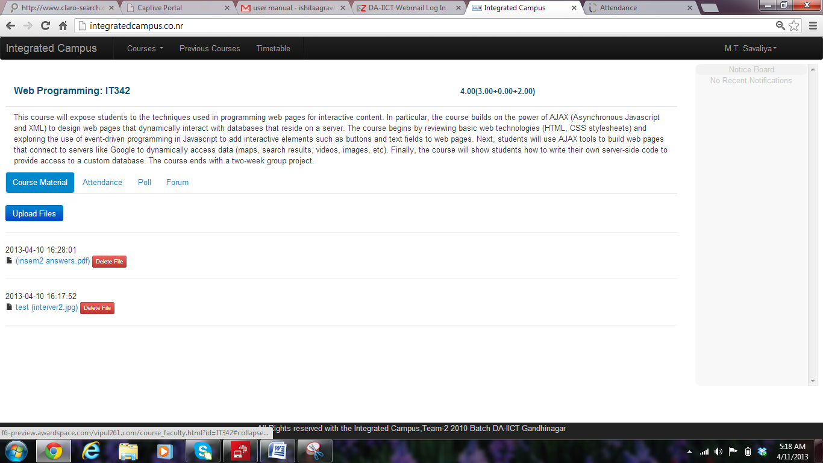

* **Upload Files**: The professor can upload files on click if ‘Upload Files’ button, the below pop up appears on click of this window. The user then needs to click on “choose file” and choose a specific file from his/her laptop or pc. Input a display name for the file and click “upload”. To close this window the user needs to click “close”.On click of “close” the user is directed back to previous page.

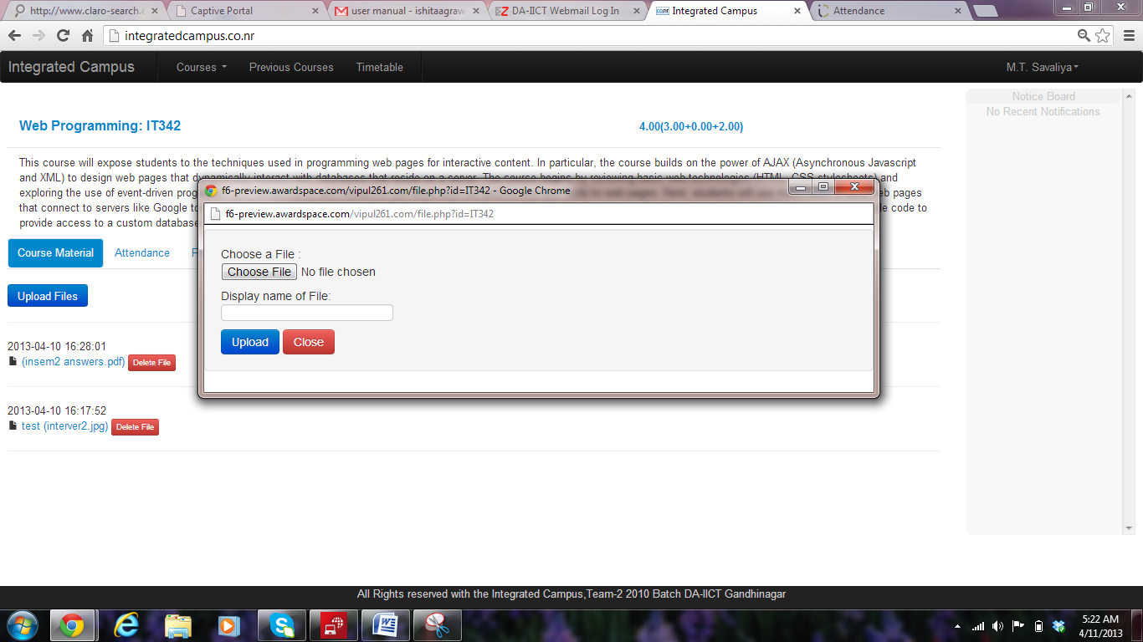

* **Delete Files :**The Professor can delete any file by clicking on ‘Delete File’ button of any specific file.

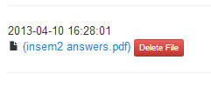

**2. Attendance Tab** – On click of this tab, Faculty can view the percentage of attendance per day in his/her course. The below page appears on click of this tab.

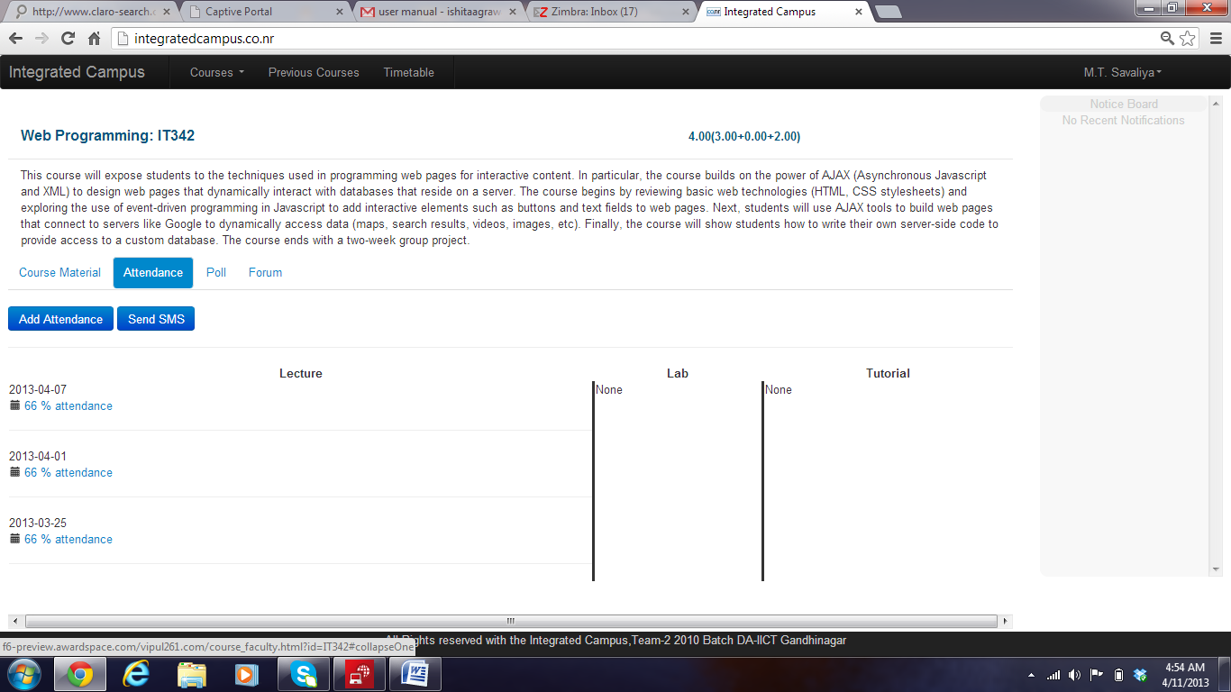

On clicking the link of attendance of specific day like ‘66% attendance”. The faculty can see the list of Id’s of students absent and present on that day, the below screen appears.

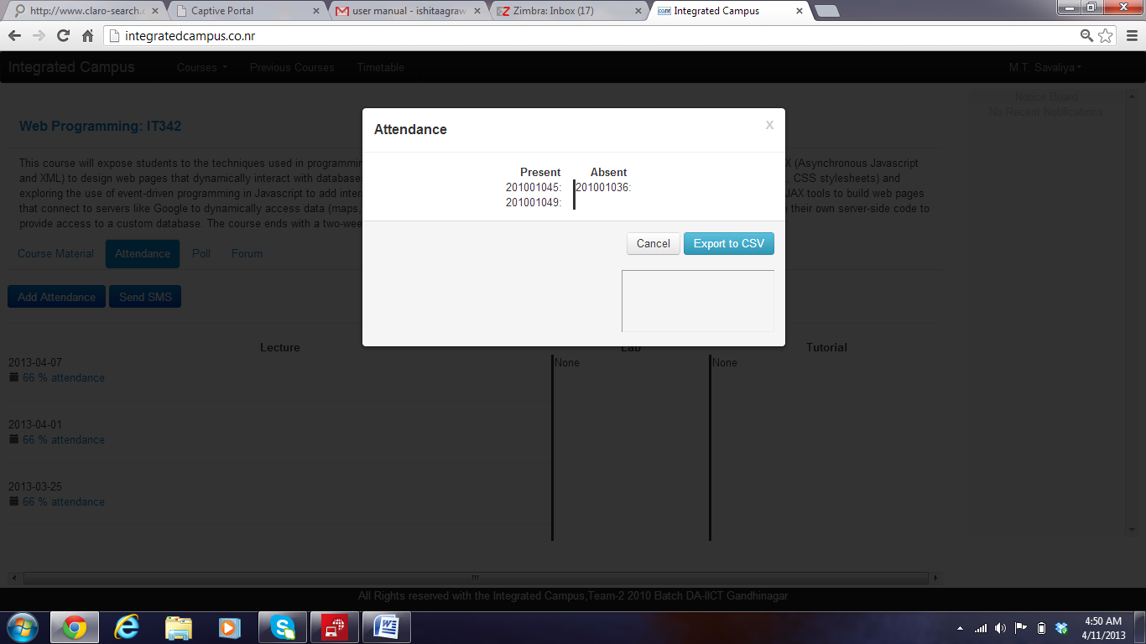

The user can also export this list of ID’s to a CSV file on click of ‘Export to CSV’ button.

On Click of ‘Cancel’ the user is directed to the previous page.

* **Adding Attendance** : The user on click of ‘Add Attendance’ button is directed to the below page,where he and she can add attendance for any specific day for lab/tutorial/lecture.

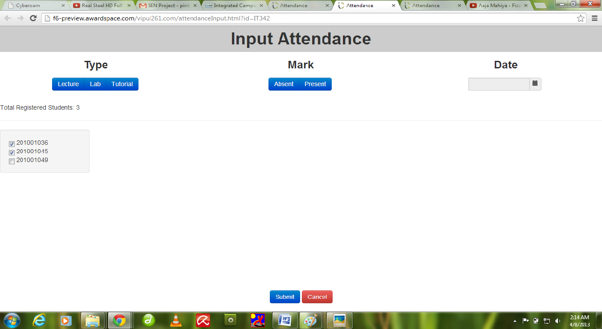

Here all the registered students’ names would be displayed and there is the option of selection as per the requirement of faculty. The faculty needs to click on tab ‘Absent/present’ depending on whether he/she wants to mark all the students Absent/present for the day. All the marked (ticked checkboxes) students get marked as Present/Absent as chosen and the rest of students get marked the opposite.

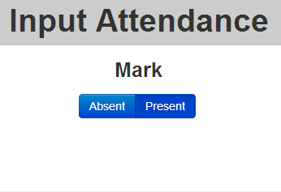

There is a date tab for the input attendance which lets the professor mark the date of the attendance.

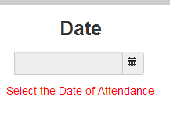

Clicking on the date tab, a calendar appears from which appropriate date can be chosen.

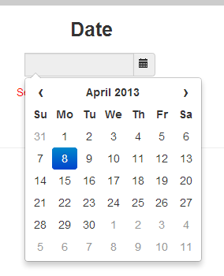

The professor also needs to chose Lab/Lecture/Tutorial to mark attendance for any specific thing.

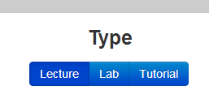

* **Sending SMS:** The Professor can also send warning messages regarding low attendance to his students by Clicking ‘Send SMS’ appearing on the bellow page.

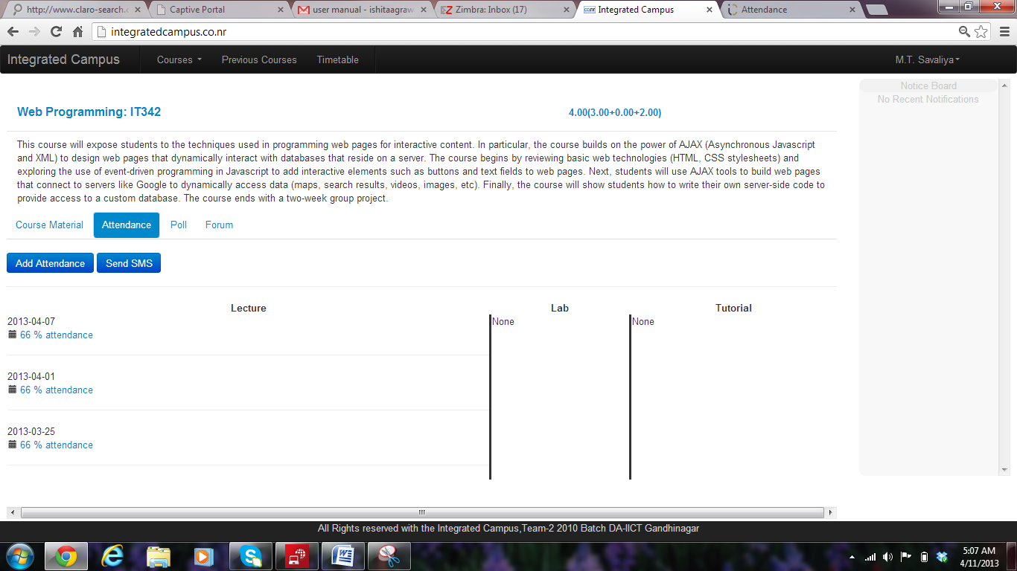

On Click of ‘Send SMS’ a pop up window appears which allows the professor to type the student id of the needed student and a short message.

On click of ‘Send’ message is sent to the respective student’s registered mobile number.

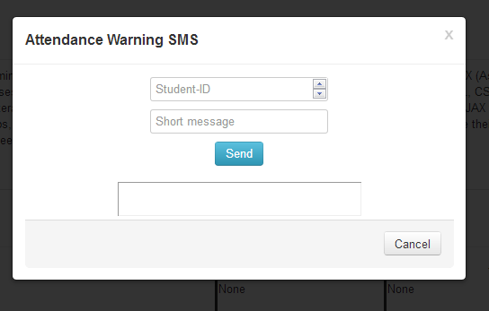

**2. Polling Tab** – On click of this tab the faculty is directed to a page where he/she can create any poll,

* **Add Poll :** The user can create a poll by entering a question and add as many options as he/she wants by clicking on ‘Add Option ‘ button.

On click of ‘Submit Poll’ the poll gets created.

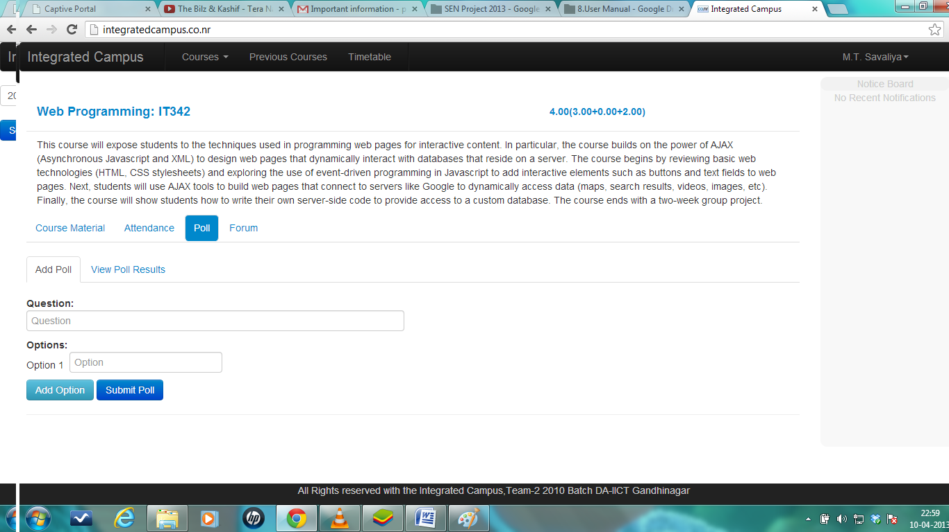

* **View Poll Results :** The user can also view poll results by clicking on ‘View Poll Results’ tab.

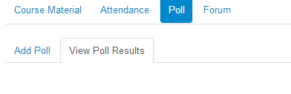

**4. Discussion forums** - Clicking on this tab directs the user to a page where he/she can ‘Create Topic’ for forum, view existing topics and post responses for the existing and newly created topics.

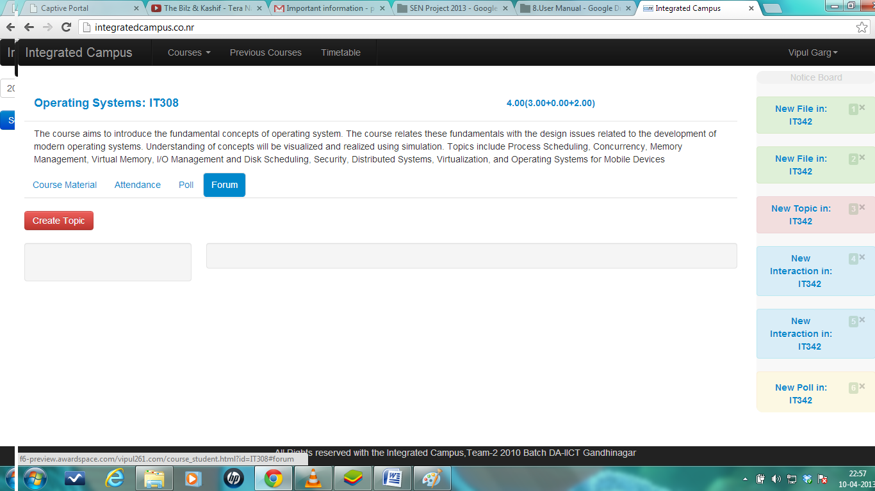

* **Create Topic** : On Click of this button the below window appears. The user needs to input the topic for discussion in the text box and click ‘GO!’ , for successful creation of new topic.

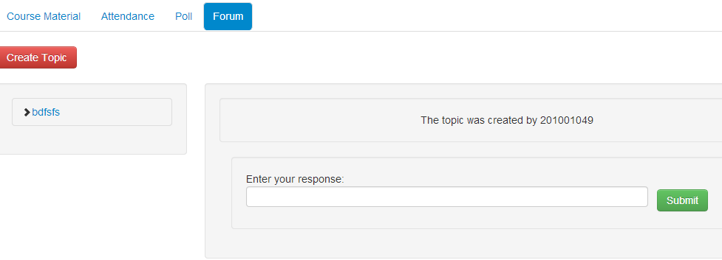



* **Entering Response** : The user can view all the responses to any specific topic by clicking on topic name .For giving a response the user needs to type his/her response in the provided textbox and click on button ‘Submit’



**5. Notice board** - The professor can view all the updates regarding the courses he/she is currently teaching in the notice board appearing in right side of the page.

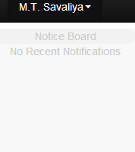

9.ADMIN LOGGED IN PAGE:

Features:

1. **ADD course –** This feature allows admin to add new courses. On clicking this, he/she is asked to fill in course details like id, name, credit and type of courses. If he wants to add multiple courses, he can click on ‘one more’.

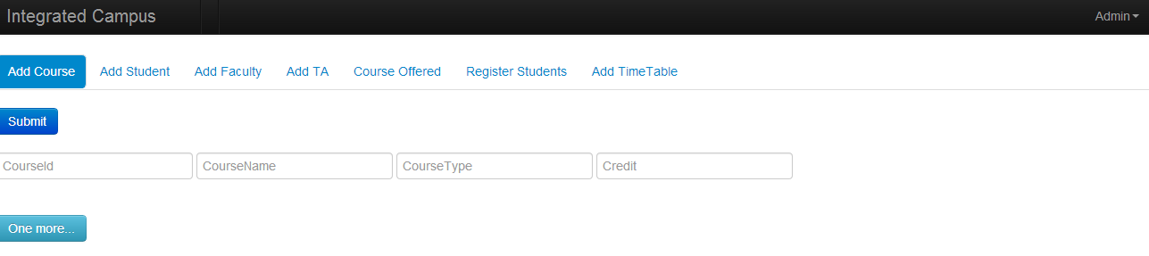

**2. Add student**- This tab allows the admin to add a new student in the college. He would need to fill in the personal and academic details of the student for the same.

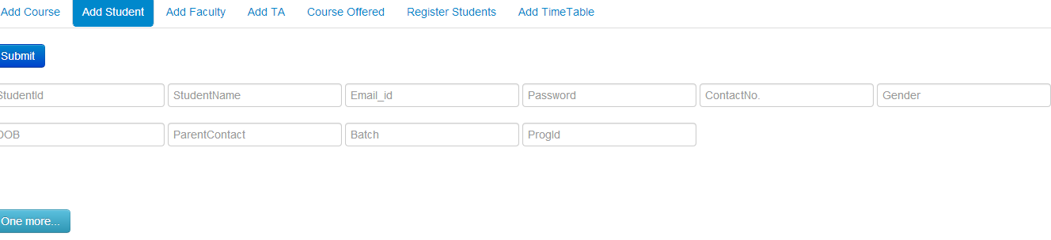

**3. Add faculty** – This tab allows the admin to add a new faculty member to the college. He/she would be required to fill in the basic faculty details for the same.

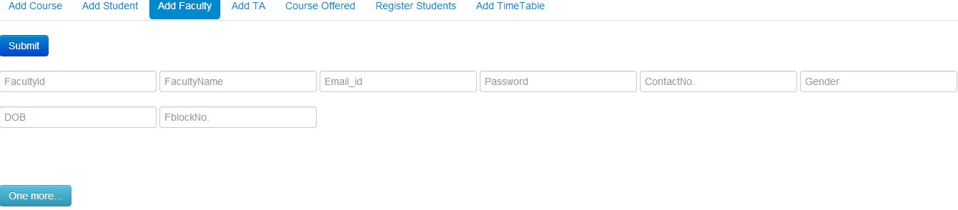

**4. Add TA** – This tab allows the admin to add a new TA to any course for any semester, he/she can add more than one course by clicking on ‘one more’.

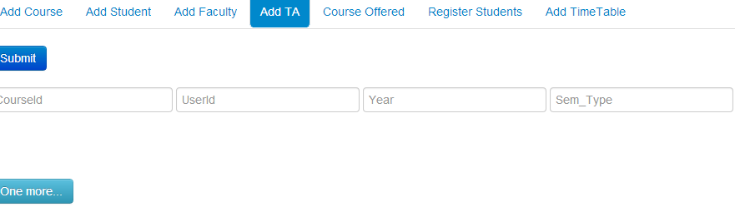

**5. Course Offered** – This tab allows the admin to add courses offered by the institute in any semester, they have to fill coursed, year of course taken, type of semester winter/autumn and faculty Id.

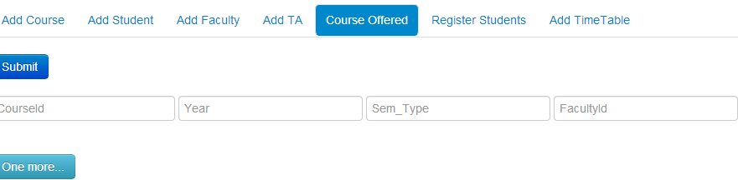

**6. Register Students** – This allows the admin to register students to any course he/she wants to take; he/she would be required to fill in the basic faculty details for the same.

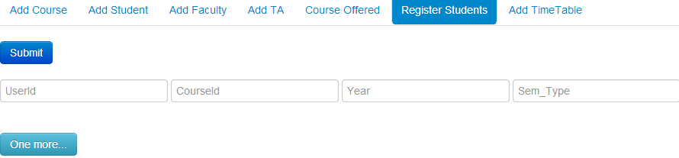

**7. Add Timetable** – This allows the admin to make the timetable for a semester. He has to just give the start and end times of all the courses.

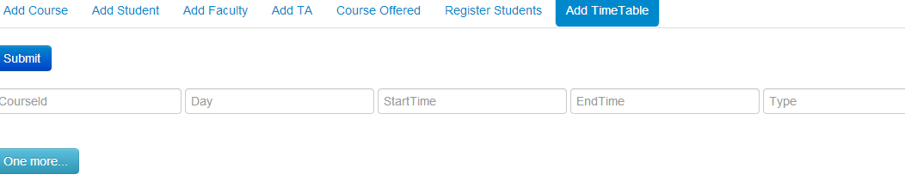

10.Teaching Assistant LOGGED IN PAGE:   
  
Features:

The TA would get all features that a normal student logged in page would get. The only extra feature is mentioned below.

1. **TAship courses** – This page shows the courses the student is a TA for.

The TA can add attendance for the course. He can also send SMS to the parents of students in case their attendance is low.

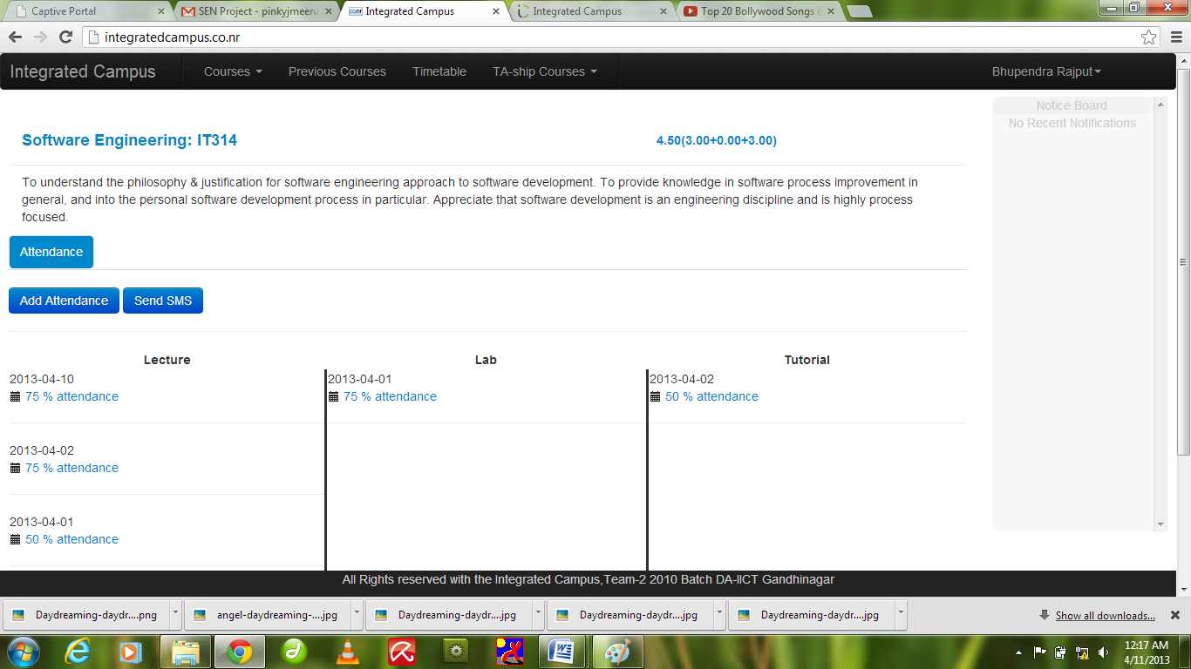

Clicking on ‘Send SMS’ the page ask to fill id of student and short warning message and then there is tab of send which sends the message, A new screen appears as seen below

